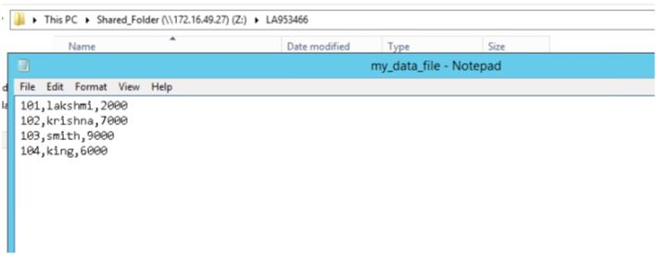1. Connect to a flat file from the shared folder and load the entire data into

another flat file. Perform this by creating a new file and import an existing file

for target.

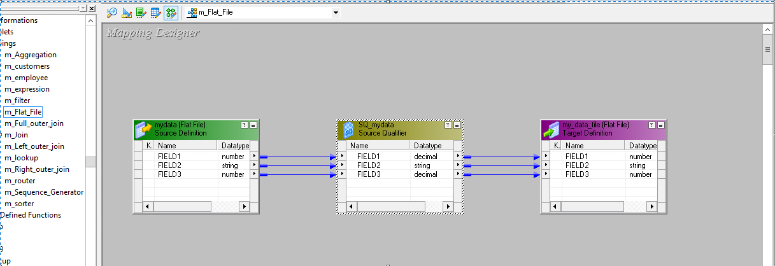

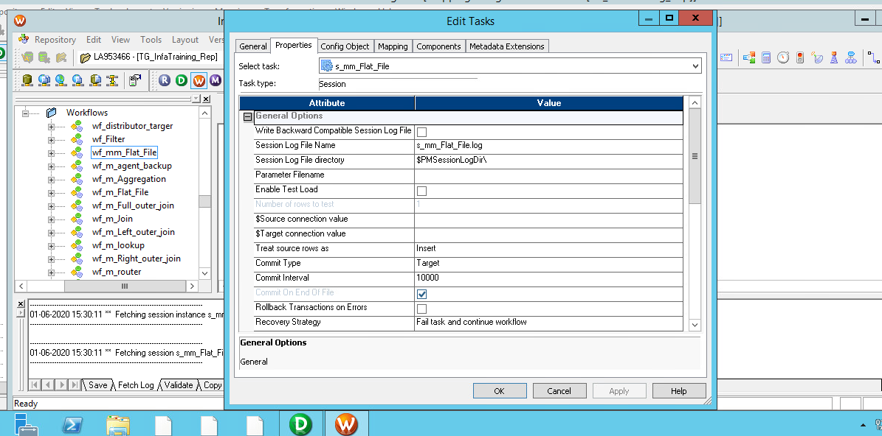

2. Connect to Database table Emp from Scott schema and load the data into

another table within the same schema. Perform this by creating new table and

using an existing table for target.

Before:

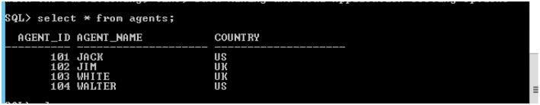

After:

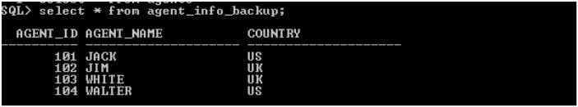

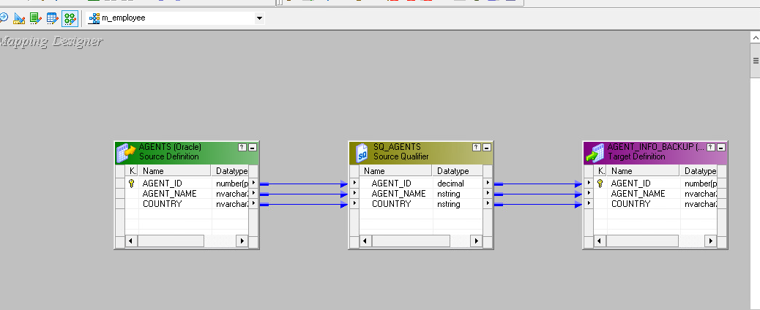

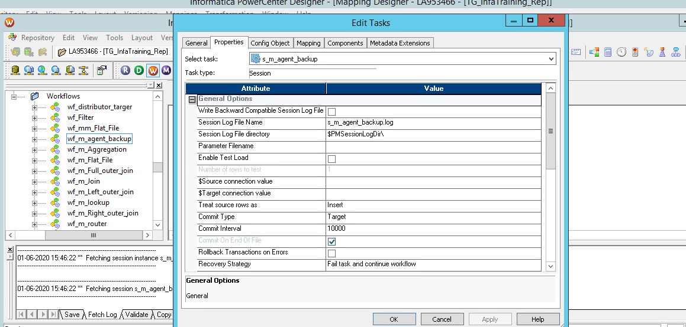

Expression Transformation : ➢ Consider the emp table as your dataset and perform the following and load into a

flat file target. ➢ First 3 characters of name and job each to be concatenated under name_job

variable. ➢ Netsal to be calculated as the sum of salary and commission. Avoid the impact of

null values. ➢ Trace the week of the year into week_year variable.

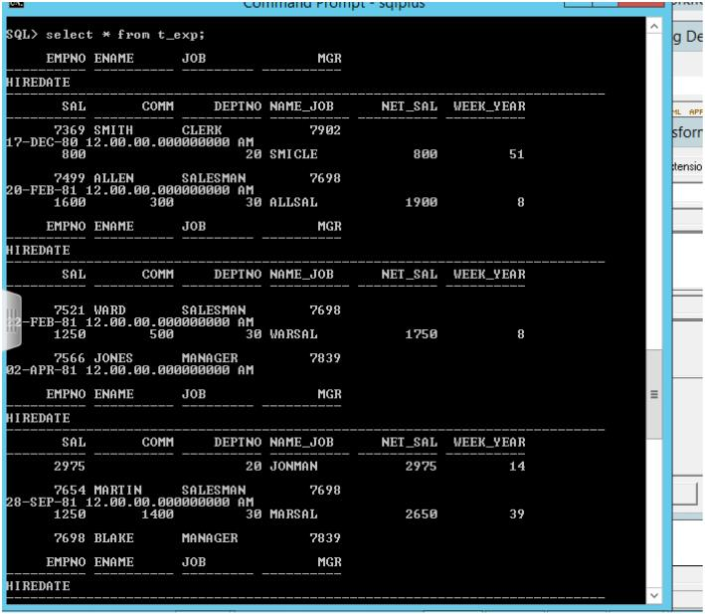

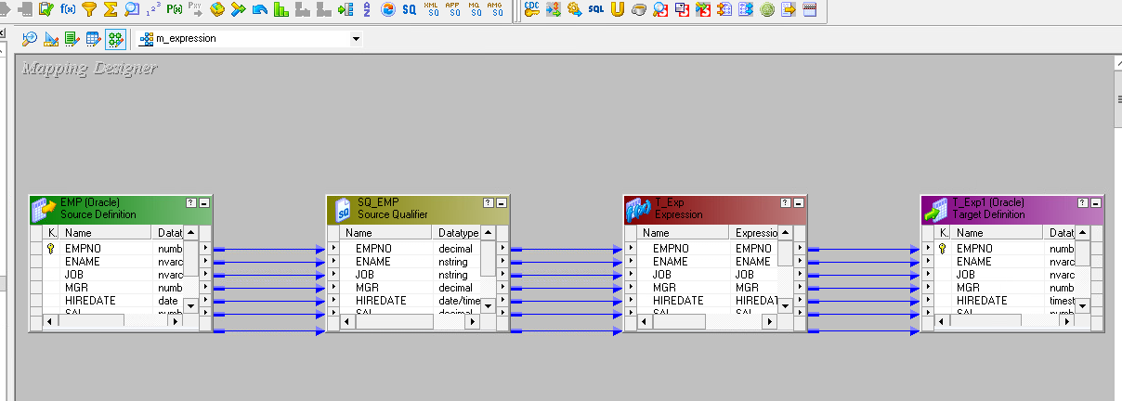

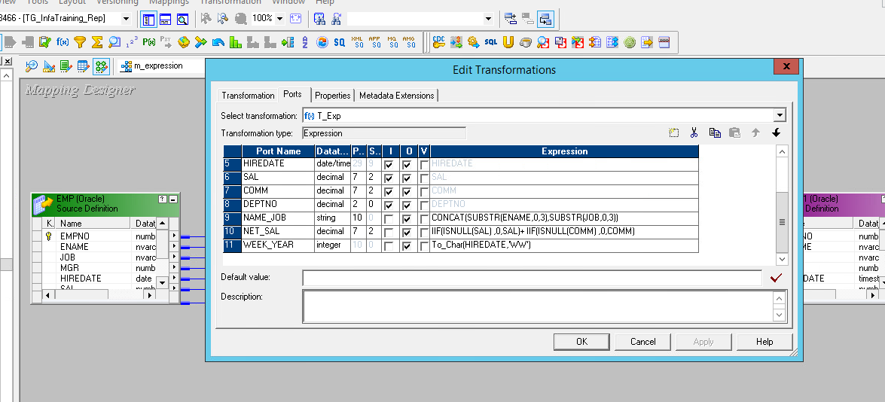

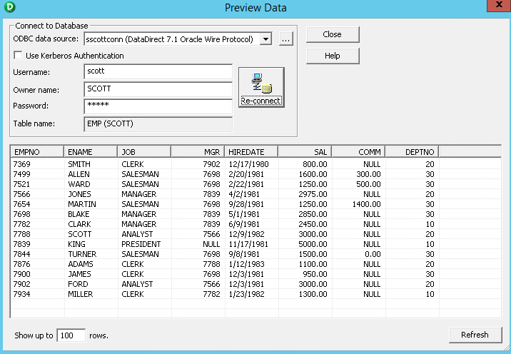

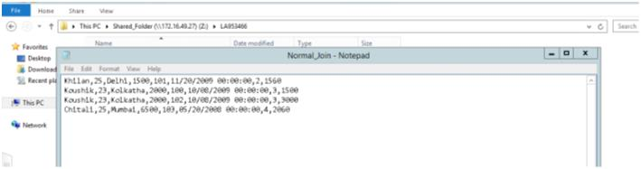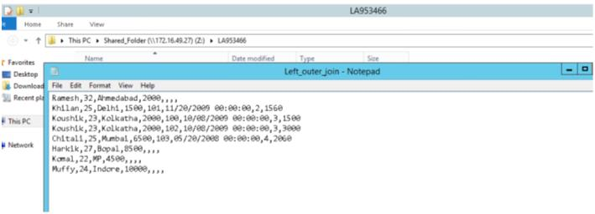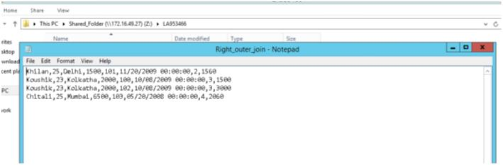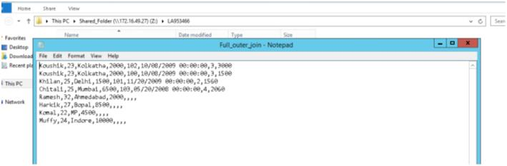Joiner Transformation:

Use the following datasets as sources and perform Normal Join, Left outer join , Right

outer join , Full outer join and load the targets at individual flat files.

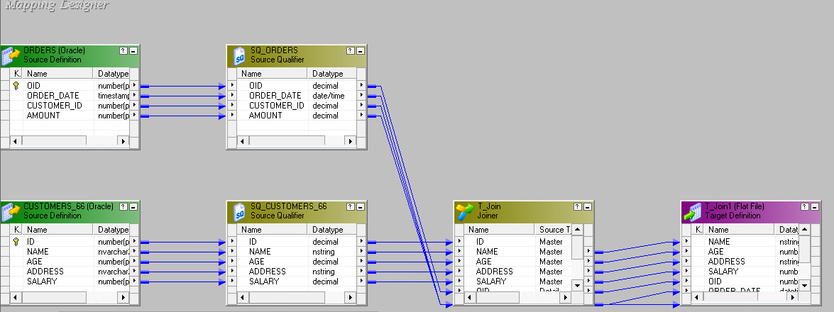

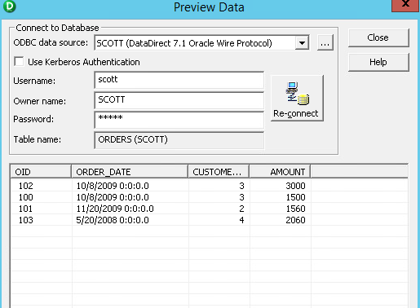

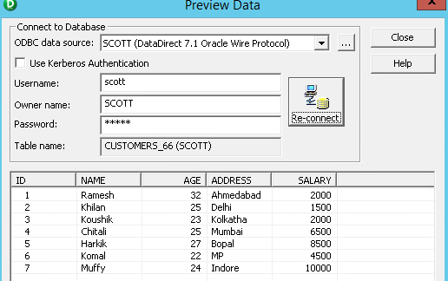

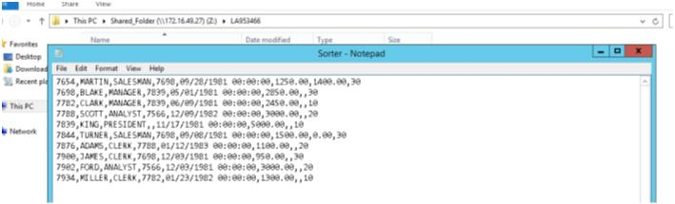Sorter: 1. Perform the following assignments using emp table. Demobld.sql script file is

available in shared folder of VDI for emp, dept, salgrade tables along with data 2. Develop a mappingto load the target with only last 10 rows (sorted ascending) of

emp table based on empno.

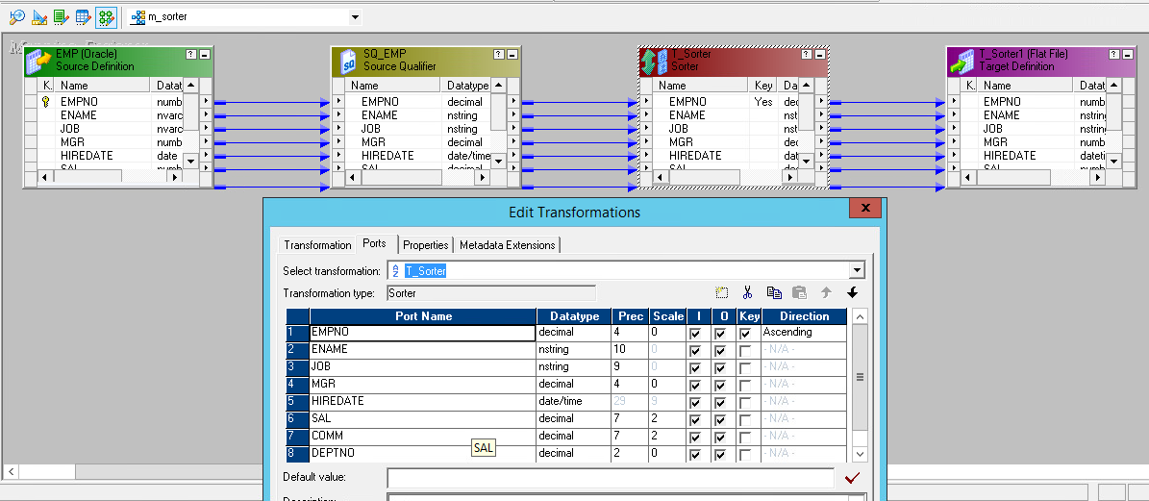



Router:

Consider Emp table and perform the following and load into flat file targets.

a. Deptno >20 b. ename length = 4 c. Netsal ( sal + comm) <4000

If none of the above criteria is true, such rows to be placed in others.txt

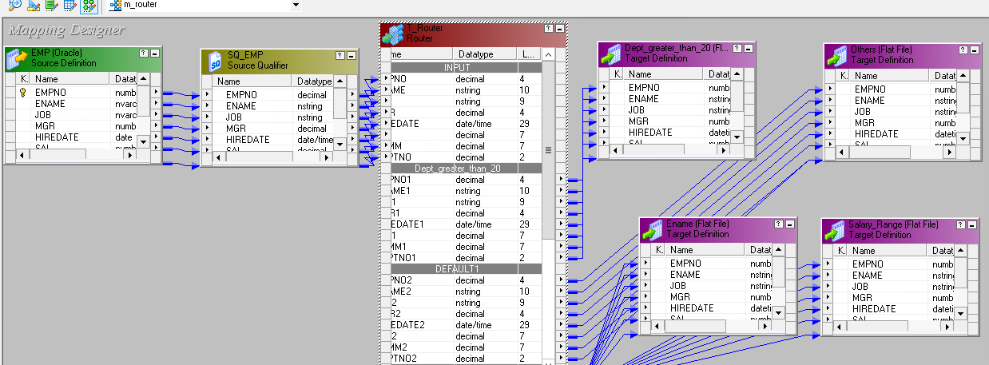



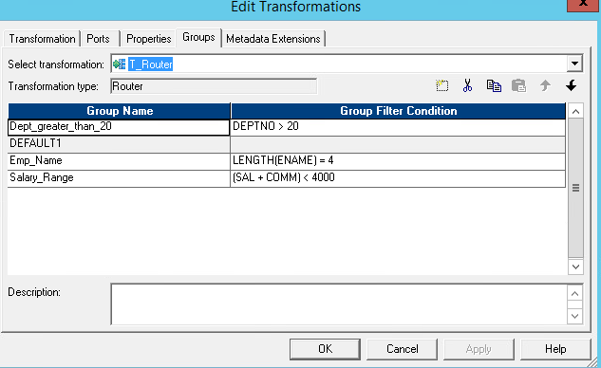

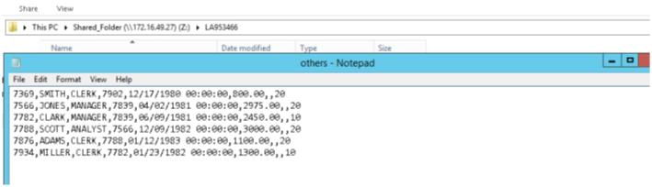

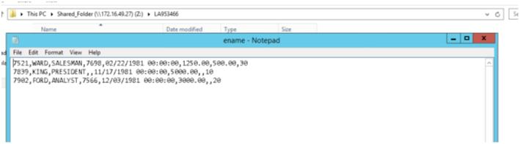

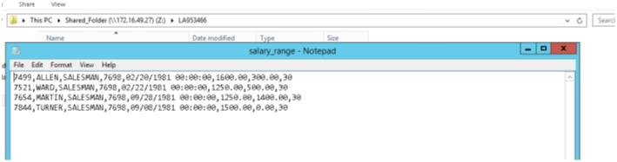

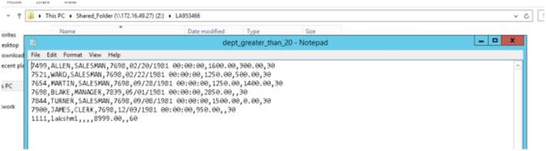

Aggregator:

i) Consider Deptno, sal from emp table and load aggregates as

mentioned below. ii) Load Max, min, sum, avg, count of salary . iii) Above aggregates categorized bydeptno

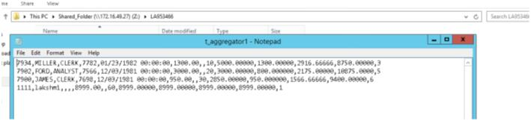

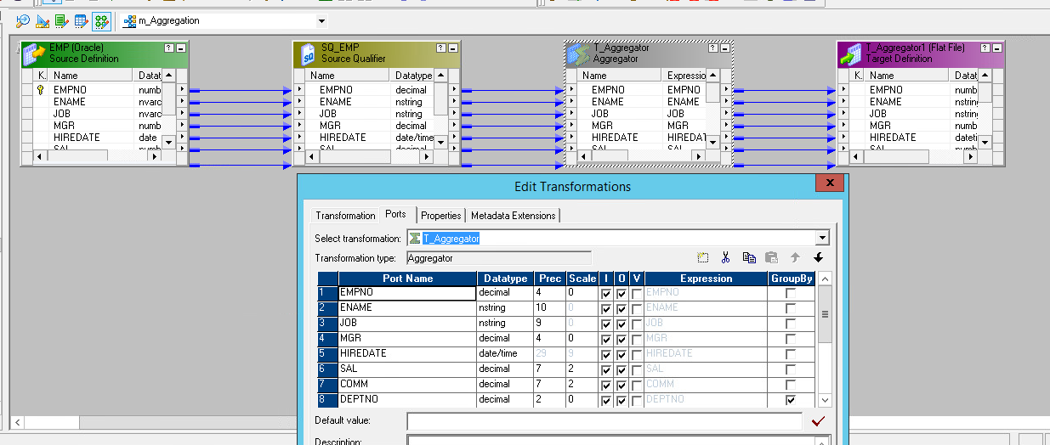



Lookup:

a) Consider the emp and dept as sources. b) Perform lookup operation to consolidate above 2 tablesand load into a database file.

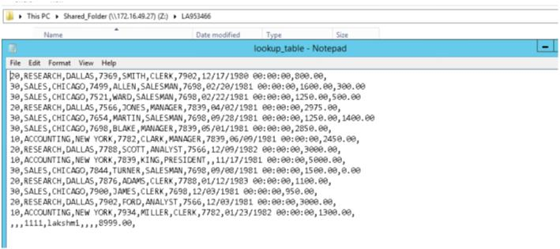

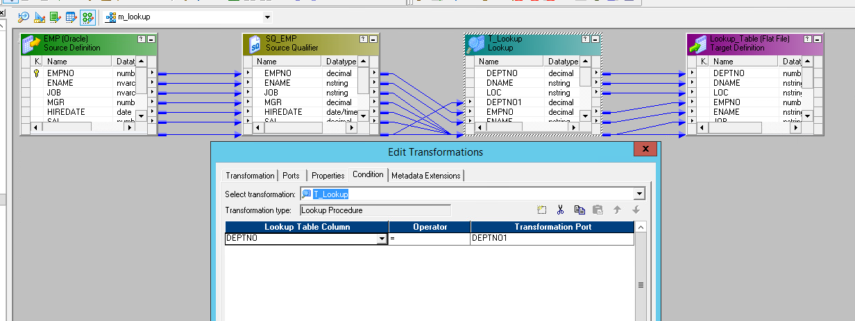

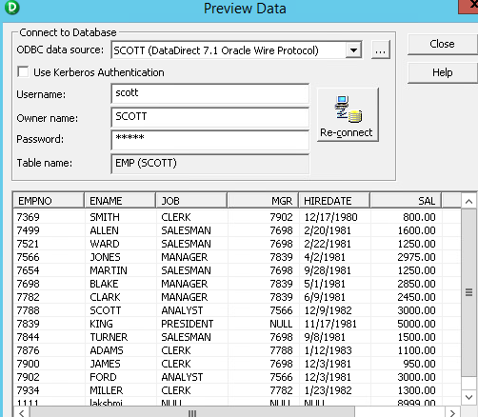

Sequence generator: i) Consider emp table, load into a target along with a new

variable SNO with a sequence of value. ii) This value should be capable of being a key element.

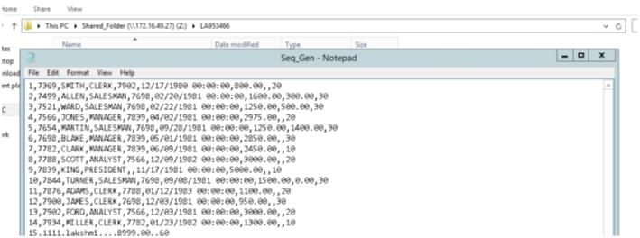

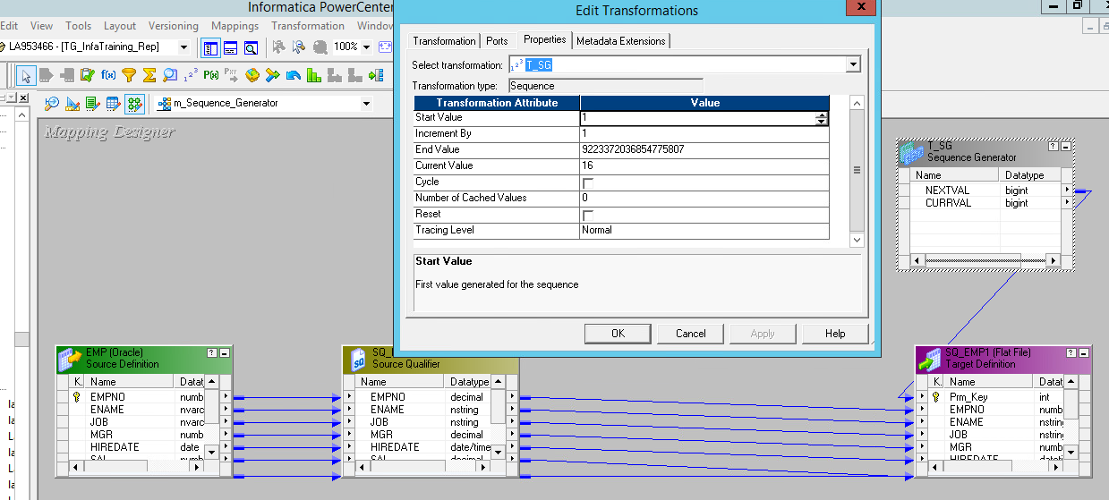



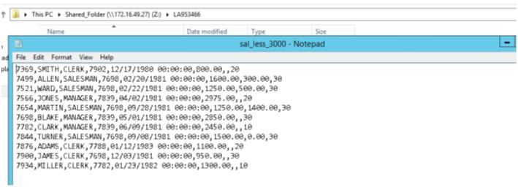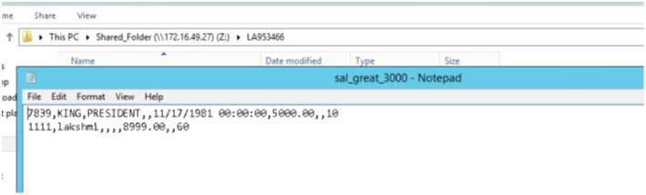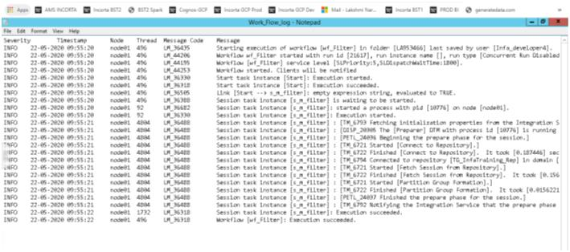Filter:

a) Read the emp table of the scott schema and load only thoserecords into the target table where the sal value is less than

3000 and load other rows into another target. b) Workflow monitor: At workflow monitor performthe following: c) Provide the session log and workflow log for a given job d) Provide the gantt chartfor the given workflow.

Workflow Log:

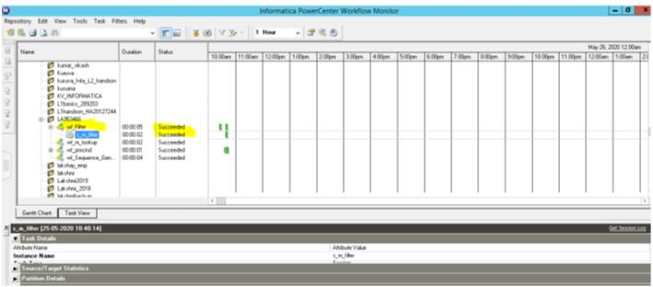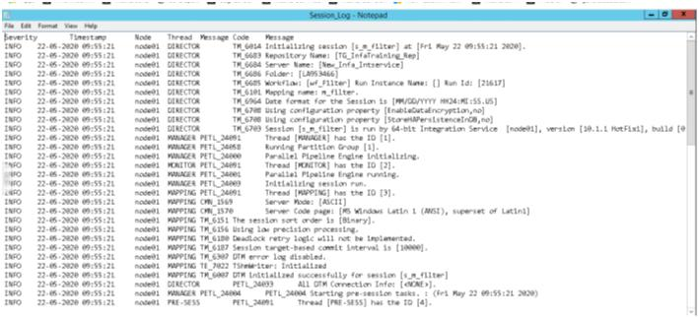Gantt Chart:

Session Log:

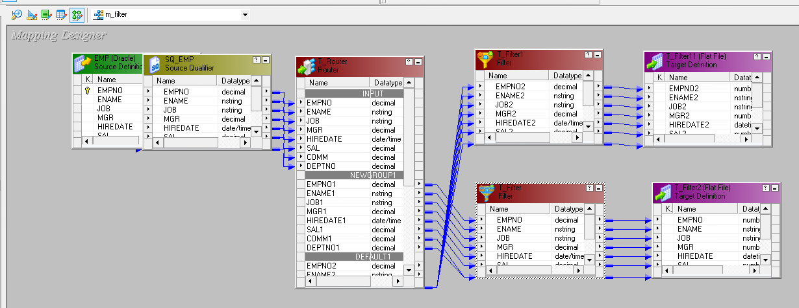

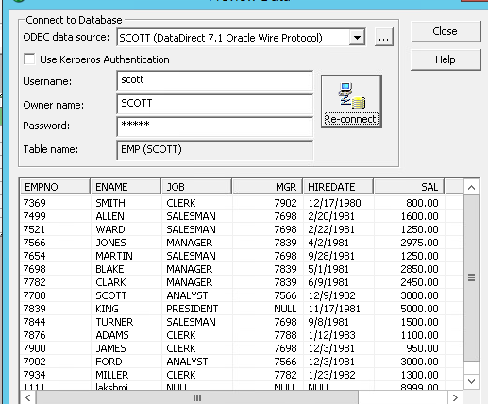

Pmcmd:

Run a job from the command line using integration service,

repository service, current folder and workflow name. Try to place

this in a batch file at command line and execute.

